  

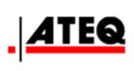 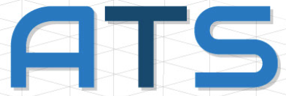 Automotive Training Group 

Autel AVI OnDemand - Training for Automotive Professionals http://www.aurodiag.com/aurocms/r/cms/www/default/img/logo300x50.png

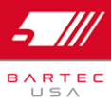 Bosch Diagnostics  

Electronic Specialties 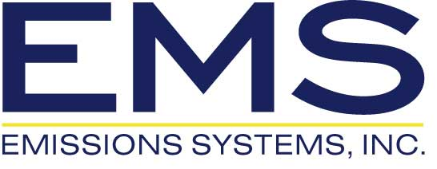 Fluke 

  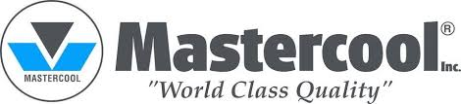 Midtronics

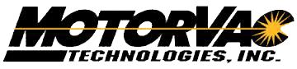 OTC Tools & Equipment 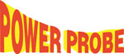 Redline Detection

http://www.robinair.com/sites/all/themes/robinair/logo.png Schumacher 

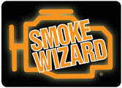 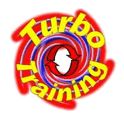 

ALSO AVAILABLE  
Dealer scan tools, subscriptions, specialty tools.

Over 100,000 additional products from hundreds of sources!

Tell us what you need and AES will package and bundle it up to meet your budget & deadlines.