Calibration:

The AES 07-600 has a calibration of 1mV per Amp. This means that every millivolt displayed on your meter is equal to one Amp. (i.e. .250V equals 250A)

Connection:

For meters using banana plug inputs, plug the 07-600’s black lead into the COM input and the red lead into the appropriate channel. For meters with an AMPS input, such as the Snap-on Vantage PGM, DO NOT connect the 07-600 to the AMPS input! The 07-600 out puts a voltage in response to current flow; therefore the meter must be set up to measure voltage.

Meters using a BNC input require the use of an adapter (AES# 08-88-M). Simply connect the 07-600 to the adapter then connect the adapter to the appropriate channel on your meter.

Use with the Snap-on Microscope, Sun LS-2000, UEI ADL-7000 and UEI ADL-7100 may require that about 1/8” of plastic shroud be cut from the probe’s banana plug connector.

Meter setup:

The voltage settings you select are based on the probe calibration (1mV/A) and the expected current form the system being tested. Since the probe is only capable of measuring a maximum of 600A (600mV) then you will never need to adjust your meter to display more than one volt on the screen. It’s always best to select a voltage setting that best matches the expected current. This will give you the most detail.

The time base and trigger selections are dependent on the test being performed. Adjust the time base and trigger until you have the desired display.

Notes:
- Some meters such as the Fluke 98, Interro PDA and the Snap-on Vantage PGM (version 3.0 and higher) have menus and setting specifically for current probes which make testing even easier. Always refer to the operator’s manual that came with your equipment. You can also call AES technical support at 559-292-7851 or send e-mail to support@aeswave.com.
- Current probes are directional. If you do not see the expected waveform or it is displayed upside-down, try reversing the probe on the conductor.

Examples:
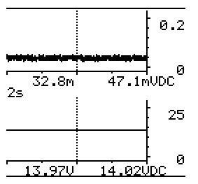
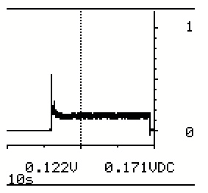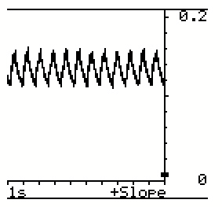
Relative compression
Charging current and voltage
Starter current

