Calibration:

The AES 07-60 has two calibration settings:
- 1mV/10mA (100mV=1A). Use for low current testing.
- 1mV/100mA (10mV=1A). Use for testing higher currents (up to 60A).

Connection:

For meters using banana plug inputs, plug the 07-60’s black lead into the COM input and the red lead into the appropriate channel. For meters with an AMPS input, such as the Snap-on Vantage, VantagePro and MODIS, DO NOT connect the 07-60 to the AMPS input! The 07-60 out puts a voltage in response to current flow; therefore the meter must be set up to measure voltage.

Meters using a BNC input require the use of an adapter (AES# 08-88-M). Simply connect the 07-60 to the adapter then connect the adapter to the appropriate channel on your meter.

Use with the Snap-on Microscope, Sun LS-2000, UEI ADL-7000 and UEI ADL-7100 may require that about 1/8” of plastic shroud be cut from the probe’s banana plug connector.

Meter setup:

For most low current testing (i.e. fuel injectors, fuel pumps, ignition coils, parasitic drain, etc.) select the 1mV/10mA calibration on the probe. On your meter, select a voltage division of 100mV/div. When using this setting, each division will represent 1A. If your meter only allows total voltage displayed adjustment, select a 0-1V display. This will allow up to 10A to be displayed. (Selecting 0-2V will allow 20A to be displayed and so on) Keep in mind that these settings are for the 1mV/10mA setting. If you select the 1mV/100mA setting, then 10mV=1A.

The time base and trigger selections are dependent on the signal being tested. Adjust the time base and trigger until you have the desired display.

Notes:
- Some meters such as the Fluke 98, Interro PDA have menus and setting specifically for current probes which make testing even easier. Always refer to the operator’s manual that came with your equipment.
- For Snap-on equipment scroll to Power User Tests and then Power User Setups then Current Probe Tests.
- DC current probes are directional. If you do not see the expected waveform or it is displayed upside-down, try reversing the probe on the conductor.

Examples:

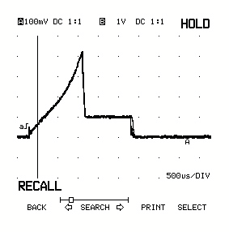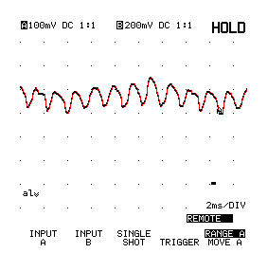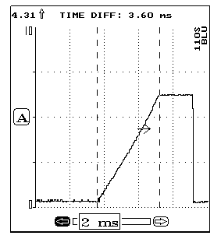
Peak and hold injector current
Fuel pump current
Ignition coil current
Troubleshooting

If you have trouble using the 07-60 low current probe, please review the following troubleshooting notes before returning the probe or contacting our technical support department:

- Is the power light coming on and staying on steady? If not, try installing a fresh battery in the probe.
- Is the low battery light on? If so, install a fresh battery in the probe.
- Have you tried replacing the battery? Often times a marginal battery may not turn on the low battery light but it may still affect the probes performance.
- What scope or meter are you using? Some scopes such as the LS-2000 and ADL-7100 require trimming the banana plug shrouds on the probe in order to make a good meter connection. Also, some meters don't have good enough resolution at low voltage levels for current tests below 1A. These meters include the LS-2000/ADL-7100, Vantage® in Waveform viewer mode and CJ-Max. Low current waveforms can be captured just fine with these meters but they may appear smaller on the screen than you expect.
- Where are you connecting at the meter? All current probes must be connected to a voltage input since they output a calibrated voltage in response to current flow. DO NOT connect to your meters amps input; this input is for a series test only.
- What calibration selection are you using on the probe? Most low current measurements require the 1mV/10mA setting. This is the first click up on the 07-60 and is better expressed as 100mV/A. Choosing and interpreting the calibration confuses many users. Take a few minutes to make sure you understand it thoroughly.
- What voltage settings are you selecting on the scope? 100mV per division is a great starting point for most meters. Using the 100mV/a calibration, each scope division will represent 1A. Lower voltage setting may be required though for a better picture on extremely low current measurements such as many injectors, battery drain and so on. On meters like the Vantage, a voltage range of 0V to 1V or 0V to .2V is a good starting point; this gives you a 0-10A or 0-2A display. Fine tune your voltage and time settings as needed. Also, make sure you are 100% familiar with your scope and its controls.
- What time setting are you using? Select a time setting that relates to the component being tested. For example, primary ignition events normally last anywhere form 2-6 milliseconds on average so 1mS/div might be a good starting point. Again, make sure you thoroughly understand your scope and it’s controls.
- Are you near any sources of electrical noise? The 07-60 is a very sensitive instrument. Sources of electrical noise such as ignition wires, alternators, etc. can affect your measurements. Try to select the best possible test point to avoid this problem.

If any of the above items do not solve the problem you should contact AES technical support. Before you contact our technical support department, make note of the following:

- What exactly is happening or not happening that indicates a problem with the probe?
- Can you send a screenshot for us to look at?
- Are there any other symptoms or unusual things about the possible failure? (i.e.: things like the loose battery connection, loose or tight switch, etc., etc.)

To contact AES technical support, e-mail support@aeswave.com or call 559-292-7851 M-F, 8:30AM-5:00 PM PST. When e-mailing, be sure to include your name, phone number, etc.

